Day 10 – Secret Sauce

Congratulations, you made it all the way to Day #10.

For some of the previous lessons you need to have access to federal facilities that do not grant access unless you’re an employee or contractor.

So how do new companies gain access to federal facilities?

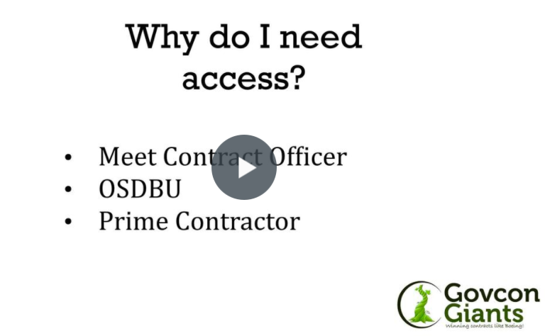

Tell me the Secret Sauce

P.S. Word to the wise. This method landed me my first contract at a new facility that I had never worked before! The value of the contract also exceeded 6 figures!

Eric Coffie

